Contents

Install Spark Worker 2

Download Spark Worker 2

Extract to Folder 3

Install Apache Spark 3

Download Apache Spark 3

Extract to Apache Spark 3

SET Environment Variables 4

SET System Variables 5

How to Run .NET UDFs 5

Useful URLS 5

## Install Spark Worker

### Download Spark Worker

<https://github.com/dotnet/spark/releases>

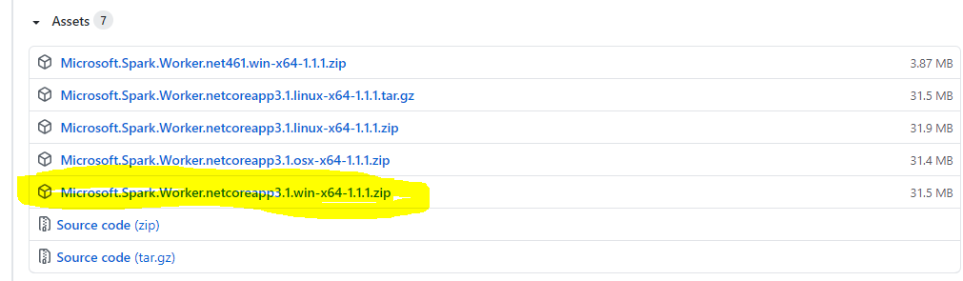

### Extract to Folder

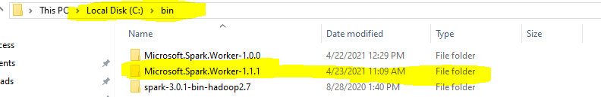

## Install Apache Spark

### Download Apache Spark

https://dotnet.microsoft.com/learn/data/spark-tutorial/install-spark

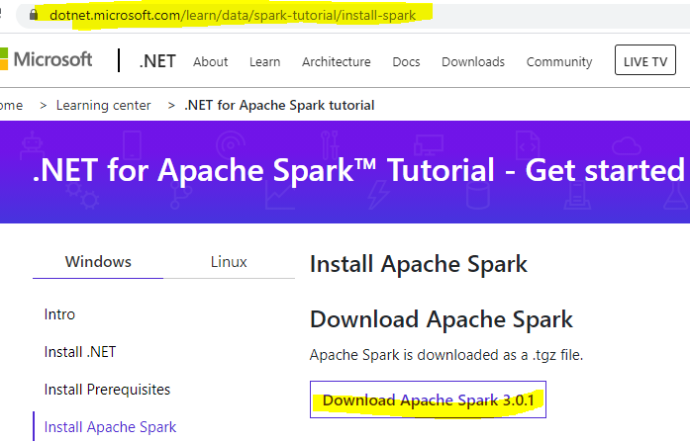

### Extract to Apache Spark

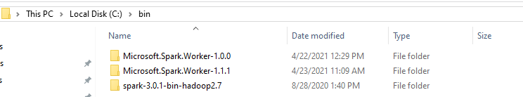

## SET Environment Variables

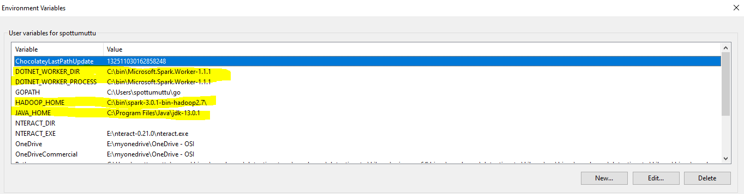

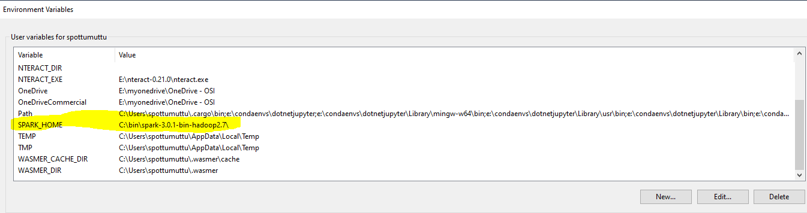

## SET System Variables

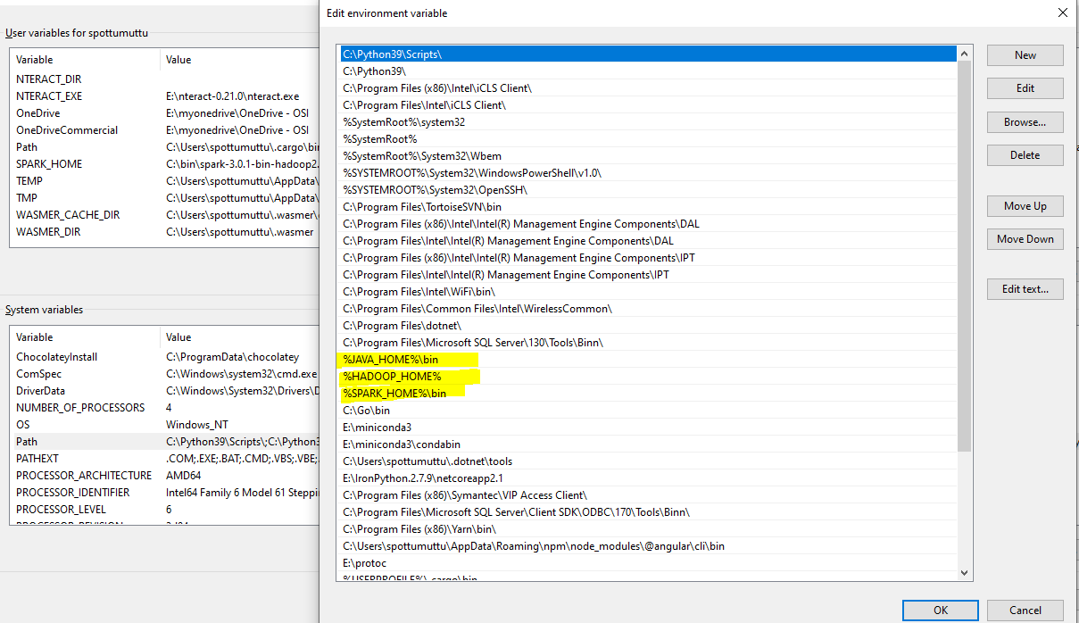

## How to Run .NET UDFs

PS E:\mygithub\sparkdotnetdemos\HelloSpark\bin\Debug\netcoreapp3.1> spark-submit --class org.apache.spark.deploy.dotnet.DotnetRunner --master local microsoft-spark-3-0_2.12-1.1.1.jar debug

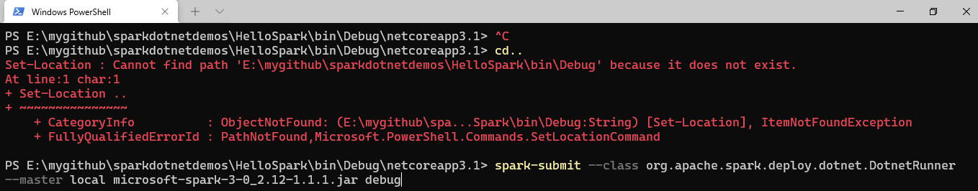

## Useful URLS

<https://dotnet.microsoft.com/learn/data/spark-tutorial/install-spark>

<https://github.com/dotnet/spark/releases>

<https://github.com/dotnet/spark#get-started>

<https://github.com/dotnet/spark/issues/242>

<https://github.com/dotnet/spark/issues/177>

<https://github.com/dotnet/spark/tree/main/deployment#preparing-your-spark-net-app>

Introducing .NET for Apache Spark Book

<https://www.apress.com/gp/book/9781484269916>